SISTER NIVEDITA MONTESSORY SCHOOL
DRAWING & HANDWRITING
CLASS – II
COMPLETE PG.NO- 3,4,&5 IN CURSIVE WRITING BOOK.
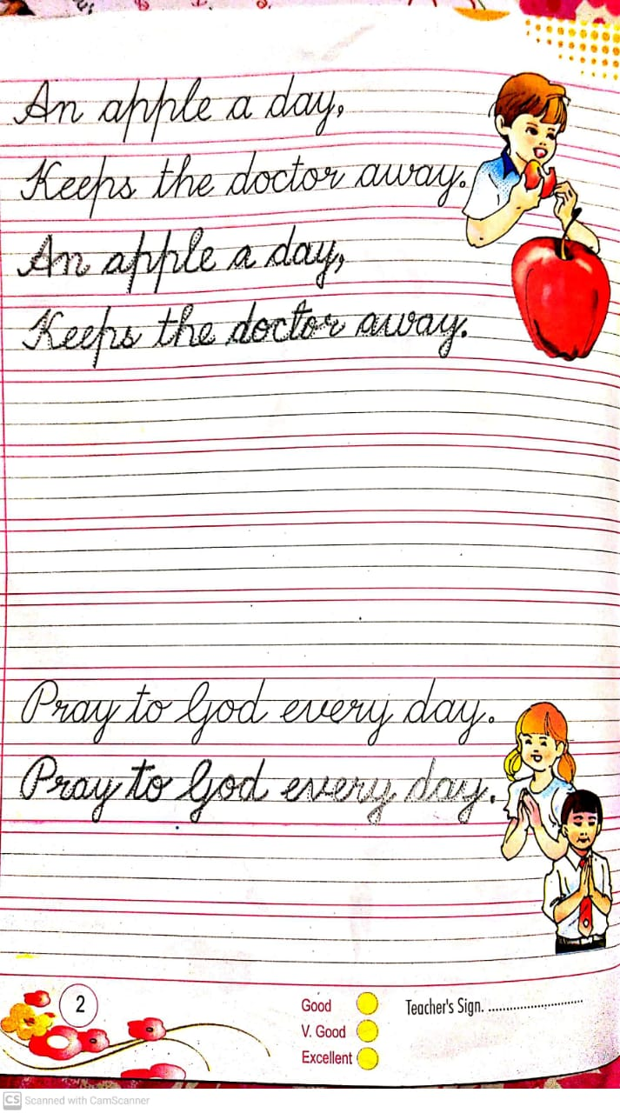
TRACE ON THE DOTTED LINES TO COMPLETE THE PICTURE &COLOUR IT.
